* 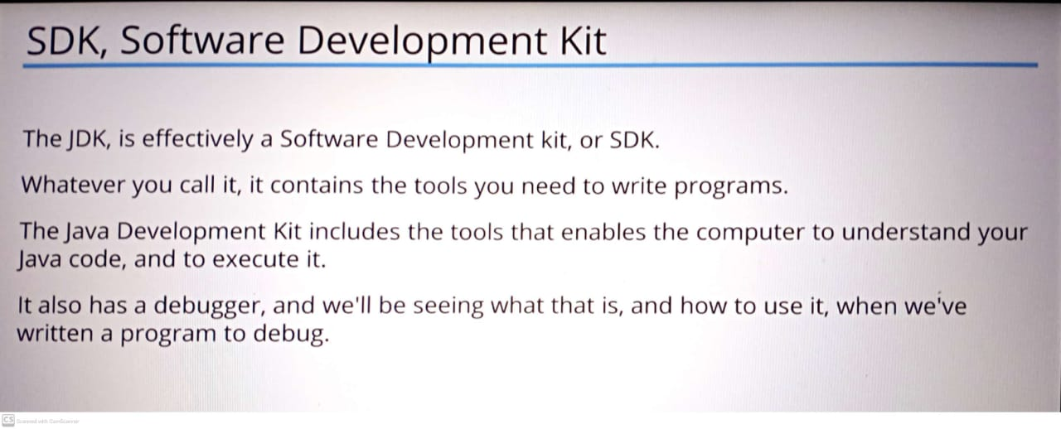
* JVM – JAVA VIRTUAL MACHINE.
* 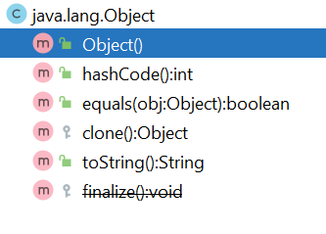

Here, “m” means method , “c” means class and with same concept “f” means field , “p” means parameter and soon……